**NAME: P V NAVI KISHORE**

**REG.NO.: 192111220**

**CODE:CSA1366**

**EXPERIMENT: 4**

**AIM:** To design turing machine gor the input a^nb^n.

**PROCEDURE:**

1. Select FOUR states and consider one as initial and another as final state.
2. Join the states using edges with directioons
3. Select the edges as INPUT and OUTPUT as a or b or c.
4. Give the input and start the simulation.

**DESIGN AND OUTPUT:**

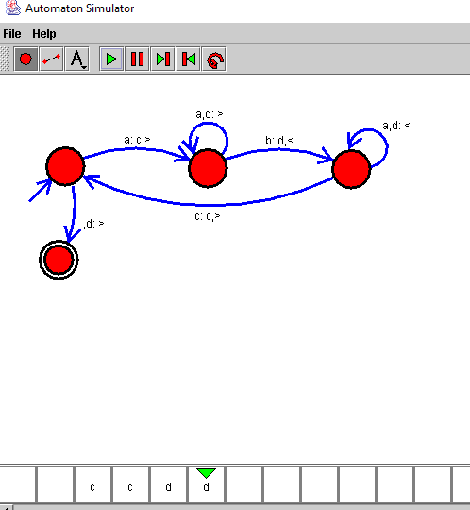

**RESULT:**

Therefore the designing of turing machine for the given input has been successfully created and stimulated.